Project Design Phase-II
Technology Stack (Architecture & Stack)
Date | 2 July 2026
Team ID
Project Name | Rising Waters
Maximum Marks | 4 Marks

Technical Architecture:
The Deliverable shall include the architectural diagram as below and the information as per the table1 & table 2
Example: Flood Risk Prediction & Early-Warning System for Rising Waters
Reference: https://developer.ibm.com/patterns/ai-powered-backend-system-for-order-processing-during-pandemics/
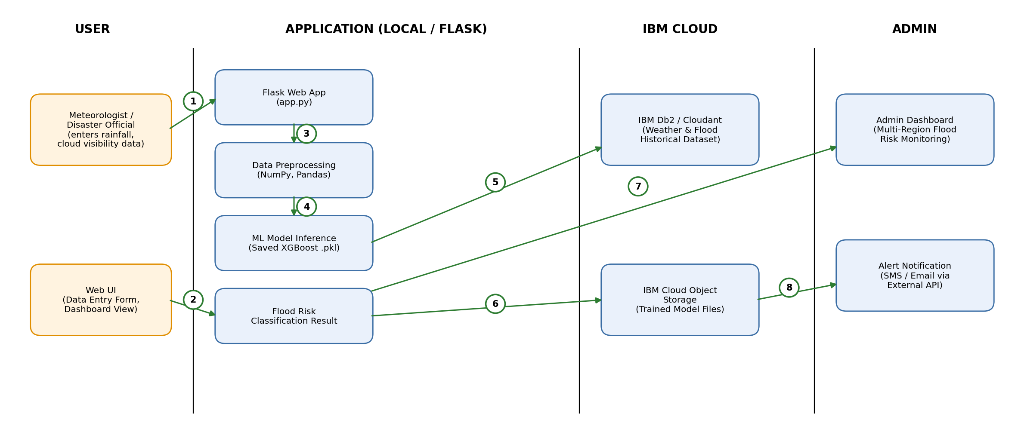
Table-1 : Components & Technologies:
S.No | Component | Description | Technology
1. | User Interface | How the meteorologist / disaster official enters rainfall, cloud visibility and seasonal data, and views flood-risk results | HTML, CSS, JavaScript, Bootstrap, Flask (Jinja2 templates)
2. | Application Logic-1 | Cleans and structures incoming weather readings before they reach the model | Python, NumPy, Pandas
3. | Application Logic-2 | Trains and compares classification models to select the best performer | Scikit-learn (Decision Tree, Random Forest, KNN), XGBoost
4. | Application Logic-3 | Loads the saved model and returns the flood-risk classification to the web app | Python, Flask, Pickle/Joblib model loading
5. | Database | Stores historical rainfall, cloud visibility and past flood-event records used for training and validation | MySQL / CSV dataset
6. | Cloud Database | Stores processed datasets and prediction logs on cloud | IBM Db2 on Cloud, IBM Cloudant
7. | File Storage | Stores the trained model file and static assets | IBM Cloud Object Storage / Local Filesystem
8. | External API-1 | Fetches live rainfall and weather-station readings for a region | IBM Weather Company API / OpenWeatherMap API
9. | External API-2 | Sends flood-risk alerts to authorities and coordinators | Twilio SMS API / SMTP Email API
10. | Machine Learning Model | Predicts the probability/class of a flood event from rainfall and cloud-visibility features | XGBoost Classifier (96.55% test accuracy)
11. | Infrastructure (Server / Cloud) | Application deployment on local system / cloud | Local: Flask dev server, Python 3.8+  Cloud: IBM Cloud Foundry / Kubernetes

Local Server Configuration: Intel i3 or above, 4 GB RAM minimum, Python 3.8+, Flask development server
Cloud Server Configuration: IBM Cloud Foundry / Kubernetes, auto-scaling container instances
Table-2: Application Characteristics:
S.No | Characteristics | Description | Technology
1. | Open-Source Frameworks | Open-source frameworks used to build, train and serve the model | Flask, Scikit-learn, XGBoost, NumPy, Pandas, Matplotlib
2. | Security Implementations | Security and access controls implemented across the application | Input validation, HTTPS/TLS, IAM access controls, encrypted DB credentials, OWASP practices
3. | Scalable Architecture | 3-tier architecture (presentation, application/ML logic, data) that can be containerised as independent services | Flask app containers on IBM Cloud Kubernetes Service
4. | Availability | Deployment across load-balanced, redundant instances so the dashboard stays reachable during monsoon season | IBM Cloud load balancer, auto-scaling, redundant Db2 instances
5. | Performance | Design choices to keep predictions fast under concurrent regional monitoring | Cached preprocessing, lightweight model inference (<1 sec/request), CDN for static assets

References:
https://c4model.com/
https://developer.ibm.com/patterns/online-order-processing-system-during-pandemic/
https://www.ibm.com/cloud/architecture
https://aws.amazon.com/architecture
https://medium.com/the-internal-startup/how-to-draw-useful-technical-architecture-diagrams-2d20c9fda90d

